Guided Capstone Project Report

Introduction

Big Mountain Resort charges skiers and riders $81 per ticket, which is a premium above average compared to its competitors in the market. Not only does the resort suspect it may not maximize relative to its position in the market, but it does not have a strong sense of what facilities and amenities are most important to visitors. Big Mountain resort needs a more data-driven business strategy for selecting a better value for their ticket price while maintaining profitable outcomes for the next year. Big Mountain is already adding an additional ski lift which will increase operating costs by about $1,540,000. Therefore, annual revenue must be more than the costs of the this new lift. The goal of this project is to find a model that can predict profitable outcomes and suggest next steps for the business.

Methods

Big Mountain Resort was one of 274 United States ski resorts included in this project. Since the goal was to find a better value for ticket price, Adult Weekend ticket price became the target variable. I generated a heat map of 29 variables, including Adult Weekend ticket prices, to visualize correlations between the independent variables and Adult Weekend ticket prices (Figure 1). After identifying important features, data were pre-processed and trained across Linear Regression and Random Forest Tree models to not only confirm these best features but to also choose the best model for predictive analyses. After training and cross-validating models, I chose to move forward with the Random Forest Tree model since there was less variability and had a Mean Absolute Error (MAE) $1 less than the Linear Regression Model. Lastly, I used the Random Forest Tree model to predict the profits and ticket prices based on 4 different scenarios, including the addition of the new ski lift, to suggest a solution that would increase ticket prices and profits for the next season.

Results

After comparing ticket prices to 28 other independent variables, initial tests suggested that vertical drop (ft), number of runs, number of fast quads, snow making (per acre) and total chairs were positively correlated with ticket prices (Figure 1). Upon training the Random Forest Tree model, data show that vertical drop (ft) was the biggest positive feature across followed by snow making (per acre), total chairs, number of fast quad lifts, and number of runs. Once trained, the model was run through 4 different scenarios. The first scenario suggested that closing the least used run would not affect revenue (Figure 2). Closing 2 to 3 successively reduces support for ticket prices. The model also suggests there is no further loss in ticket price from closing 3, 4, or 5, runs, but closing 6 would lead to a large drop of ticket price and so revenue (Figure 2). The second scenario modeled the additional lift that Big Mountain is adding. This model increases support for ticket price by $1.99 and could potentially bring in $3,474,638 for the whole season. The third scenario added 2 acres of snowmaking in addition to all additional amenities from the second scenario and suggested an increased support for ticket price by $1.99, similar to scenario two. The last scenario called for increasing the longest run by 0.2 miles adding 4 acres of snow making capability, but there was no difference in ticket price.

Decision Recommendations

The final model suggests that with the addition of a new ski lift (Scenario 2), Big Mountain should increase ticket prices by $1.99 each with an expected revenue of about $3,474,638. Adding 2 acres of snowmaking in addition to Scenario 2 makes no difference in ticket price, so its best to prioritize just the addition of the new lift. If Big Mountain chooses to close any ski lifts, they should only close the least used run, since any additional runs closed beyond that will not support ticket value. Lastly, adding 0.2 miles to Big Mountain’s longest run and 4 acres of snow making makes no difference in ticket price, so this scenario can be excluded from future business plans.

Conclusion

In the next season, we hope Big Mountain Resort would get at least 350,000 customers skiing an average of 5 days. We used a Random Forest Tree model and found that vertical drop (ft) was the biggest positive feature which benefits Big Mountain and its recently installed chair lift contributing value to the resort. With this new feature adding 1 ski run and 150 ft to the skiable terrain, Big Mountain is able to increase their ticket price tp $82.99 since the value of the resort will also increase. Even with the operating costs of the new lift ($1,540,000), Big Mountain would still be expected to make a profit of about $2,000,000 in the next season. This outcome seems promising, however, this study did not include other operating cost information that may decrease the expected profits suggested by this model alone. Additionally, the features that this model suggest were Big Mountain’s best features, may not be what skiers coming to Big Mountain are looking for. If these recommendations do not work for next season, or if additional scenarios are needed, this code is publicly available to use to ensure Big Mountain stays up to par with ticket price that aligns with their value.

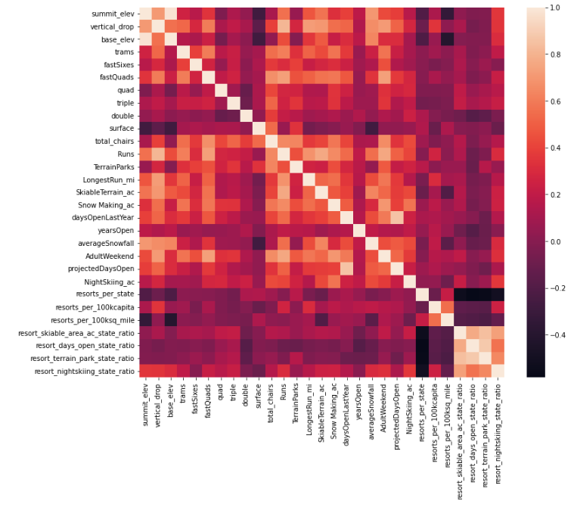

Figure 1: Heat map of the relationship of 29 variables included in this study. Adult Weekend ticket price can be found on both axes. The legend on the right describes highly correlated variables with a beige color and negatively correlated variables with a black color. This heat map shows which variables are more highly correlated with the target variable, Adult Weekend ticket prices, than others.

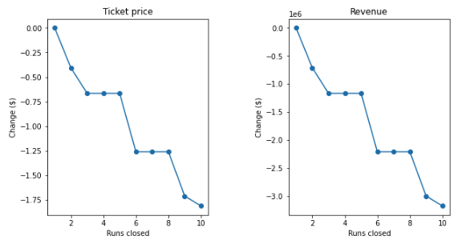

Figure 2: Random forest tree model of closing 10 runs at Big Mountain and its predicted revenue outcomes. Each scenario was looped in the random forest tree model and results. Since ticket price directly affects revenue, both graphs show the same decreasing trend.